ACSL
American Computer Science League
2012 - 2013

Contest #3

Classroom Division
1. Graph Theory

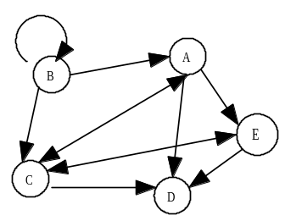

Write the adjacency matrix for
the following directed graph:

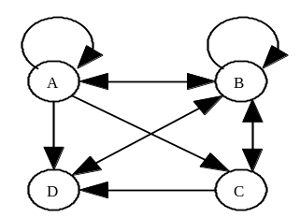

- Graph Theory
How many paths of length 2
exist from vertex B?

3. Boolean Algebra
Simplify the following Boolean expression:
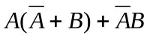

- Boolean Algebra
How many ordered triples make the following Boolean
expression true?
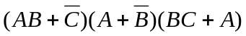

- What Does This Program Do?
What is the final value of z after the program is run?
dim a(50)
c = 0 : z=0
for i = 1 to 50
a(i)=i
next i
for i = 2 to 50
for j = 2 to 8
if a(i)/j= 1 then c =c+1
for k = 2*j to 50 step j
a(k)=0
next k
next j
next i
for b = 2 to 50
if a(b)<>0 then z = z + 1
next b
print z
end

xxxxxxxxxxxxxxxxxxxx

